

Wanderlustt

Travel Company

November 15

Wanderlustt
Prepared by: Abhishek.J.Gaikwad


Database System & Analytics Overview

Project Overview
This SQL project is built for Wanderlustt Travel Company, a global travel business offering curated packages, hotel bookings, and destination-wise experiences.

The project contains 5 main tables:
1. Customers – customer information
2. Destinations – travel destinations offered
3. HotelBookings – hotel & trip booking details
4. PaymentsReceived – payments from customers
5. PaymentsToVendors – payouts to hotels/vendors

QUERIES:

CREATING DATABASE:

Question: Creating Database

Input Query:
Output:
Insight: A separate database is created to manage bookings.

CREATE TABLE:
Question: Create a table of Customers where there are customer_id, full_name, Email, Phone, Country with appropriate constraints.

Input Query:
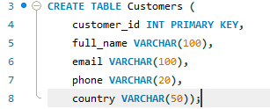
Output:

Insight: Defines the structure for storing customer data and enforces data integrity
through primary and foreign keys, ensuring each customer_id is unique and linked to a valid customer name.

INSERTING VALUES:

Question: Inserting values in each column.

Input Query:
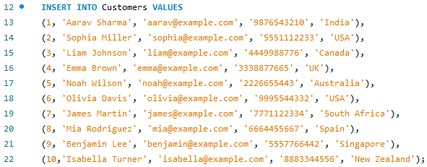

Output:
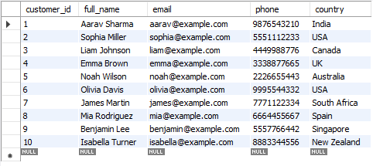
Insight: Populates the tables with sample data, which is essential for testing,
developing, and demonstrating the functionality of all other queries.
ENTITY RELATIONSHIP DIAGRAM:
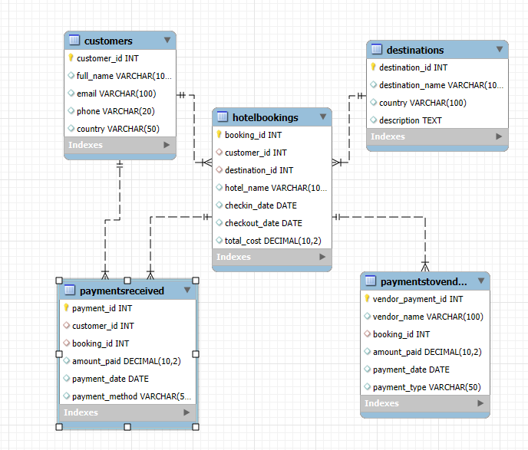
1. Total Revenue Received (AGGREGATE FUNCTION):

Question: find total revenue received

Input Query:
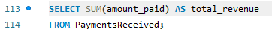
Output:
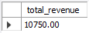
Insight: provides a sum of revenue by counting the amount paid by customers.
2. Total Vendor Expenses (AGGREGATE FUNCTION):

Question: find total expenditure on vendors & hotels

Input Query:
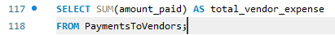

Output:
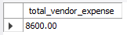

Insight: provides a sum of expenditure by counting the amount paid to hotels and vendors.

3. Net Profit (Revenue – Vendor Payments):

Question: find the Net profit

Input Query:
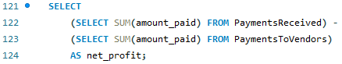

Output:
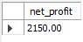
Insight: provides Net profit made by company by deducting total revenue by total vendor expense.

4. Revenue per Destination (Join clause) :

Question: find revenue made by each destination

Input Query:
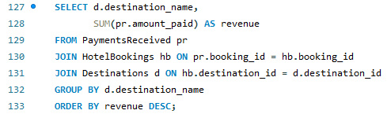

Output:
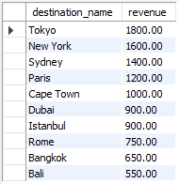
Insight: provides with revenue made by each destination.

5. Top 5 Customers by Spending (Limit) :

Question: to find top 5 customers

Input Query:
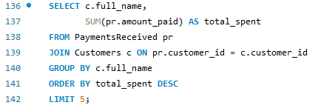

Output:
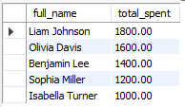
Insight: provides the top 5 customers and who spent the most on trips.

6. Vendor/hotels Expense Report per Booking (Join clause) :

Question: to find vendor/hotels expense per booking

Input Query:
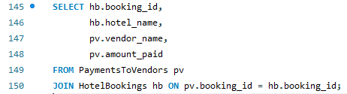

Output:
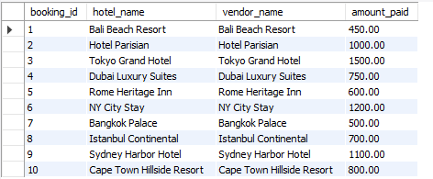
Insight: provides the expense on vendors/hotels per booking.

7. Most Popular Destination (by number of bookings):

Question: to find most popular destination

Input Query:
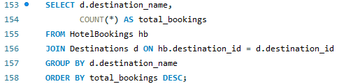

Output:
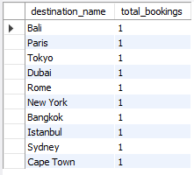
Insight: provides the most popular destinations.

8. Monthly Revenue Summary:

Question: to find monthly revenue summary of the company

Input Query:
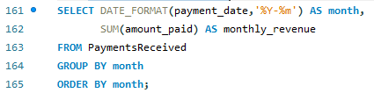

Output:
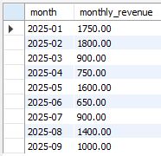
Insight: provides the monthly revenue summary .

9. Average Trip Cost per Destination:

Question: find average trip cost per destination

Input Query :
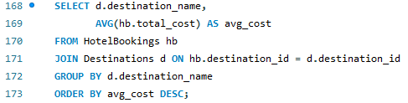

Output:
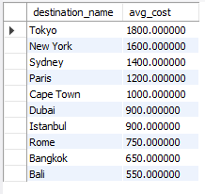
Insight: provides average cost for trip for all the destination.

10. Profit Per Booking:

Question: To find profit made on booking

Input Query:
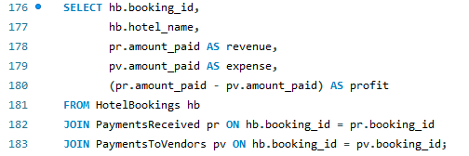

Output:
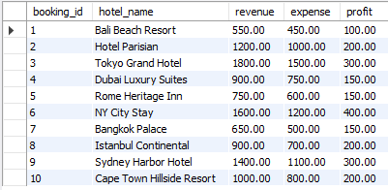

Insight: provides the profit made per booking at vendor/hotels.
Summary – Wanderlustt SQL Project
This project presents a complete SQL-based data system for Wanderlustt Travel Company, designed to manage customers, destinations, bookings, and financial transactions. The database consists of five core tables—Customers, Destinations, HotelBookings, PaymentsReceived, and PaymentsToVendors—each supporting efficient storage, relational integrity, and smooth business operations.
A series of SQL queries demonstrate essential functionalities, including data creation, insertion, aggregation, and joins. Key analytical queries calculate total revenue, vendor expenses, net profit, revenue by destination, top customers, monthly earnings, and profit per booking. These insights help the company understand its financial performance, customer spending behavior, and popular travel locations.
Overall, the project delivers a structured relational database, meaningful analytics, and clear business insights that support decision-making and operational efficiency for the Wanderlustt Travel Company.

